**Experiment 7**

**Student Name:** Sahil Kaundal **UID:** 21BCS8197

**Branch:** CSE (Lateral Entry)  **Section/Group:** 616/A

**Semester:** 6th **Date of Performance:** 24/04/2023

**Subject Name:** Internet of Things Lab **Subject Code:** 20CSP-358

1. **Aim:**

To display data generated by sensor on LCD using Arduino/Raspberry Pi.

1. **Objective:**

* Learn about LCD in detail.
* Learn about IoT programming.
* Display data generated by sensor on LCD using Arduino/Raspberry Pi.

1. **Requirements:**

* Arduino Uno R3 board
* LCD
* Jumper Wires

1. **Procedure:**

**Arduino LCD Display**

The LCD (**Liquid Crystal Display**) is a type of display that uses the liquid crystals for its operation. The library that allows us to control the [LCD](https://www.javatpoint.com/lcd-full-form) display is called **Liquid Crystal Library.**

The library is based on a compatible chipset called **Hitachi HD44780**. It is found on most of the LCDs that are based on text. It works with either an 8-bit mode or 4-bit mode. Here, the bit mode signifies the data lines in addition to the enable, rs, and rw control lines (optional).

### **LCD Structure**

The LCD display has a 16-pin interface.

The structure of the LCD is shown below.

The Liquid Crystal Display has a parallel interface. It means that the microcontroller operates several pins at once to control the LCD display.

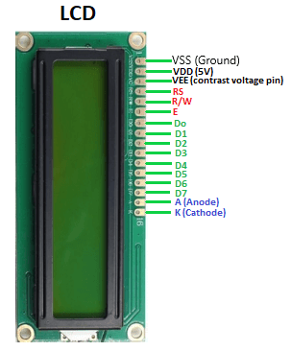

* **Pin1(Vss)**: Ground pin of the LCD module.
* **Pin2(Vcc)**: Power to LCD module (+5V supply is given to this pin)
* **Pin3(VEE)**: Contrast adjustment pin. This is done by connecting the ends of a 10K potentiometer to +5V and ground and then connecting the slider pin to the VEE pin. The voltage at the VEE pin defines the contrast. The normal setting is between 0.4 and 0.9V.
* **Pin4(RS)**: Register select pin. The JHD162A has two registers namely command register and data register. Logic HIGH at RS pin selects data register and logic LOW at RS pin selects command register. If we make the RS pin HIGH and feed an input to the data lines (DB0 to DB7), this input will be treated as data to display on LCD screen. If we make the RS pin LOW and feed an input to the data lines, then this will be treated as a command (a command to be written to LCD controller – like positioning cursor or clear screen or scroll).
* **Pin5(R/W)**: Read/Write modes. This pin is used for selecting between read and write modes. Logic HIGH at this pin activates read mode and logic LOW at this pin activates write mode.
* **Pin6(E)**: This pin is meant for enabling the LCD module. A HIGH to LOW signal at this pin will enable the module.
* **Pin7(DB0) to Pin14(DB7)**:  These are data pins. The commands and data are fed to the LCD module though these pins.
* **Pin15(LED+)**: Anode of the back light LED. When operated on 5V, a 560-ohm resistor should be connected in series to this pin. In Arduino based projects the back light LED can be powered from the 3.3V source on the Arduino board.
* **Pin16(LED-)**: Cathode of the back light LED.

1. **Steps/Program:**

#include "LiquidCrystal.h"

LiquidCrystal lcd(8,7,6,5,4,3);

int GAS_VAL = 0;

void setup()

{

pinMode(A0, INPUT);

Serial.begin(9600);

lcd.begin(16,2);

lcd.setCursor(0,0);

lcd.print(" Experiment 7 ");

}

void loop()

{

GAS_VAL = analogRead(A0);

Serial.println(GAS_VAL);

if (GAS_VAL > 500)

{

lcd.setCursor(0,1);

lcd.print(" GAS Detected");

}

else

{

lcd.setCursor(0,1);

lcd.print(" GAS Not Detect");

}

delay(10); // Delay a little bit to improve simulation performance

}

1. **Output:**

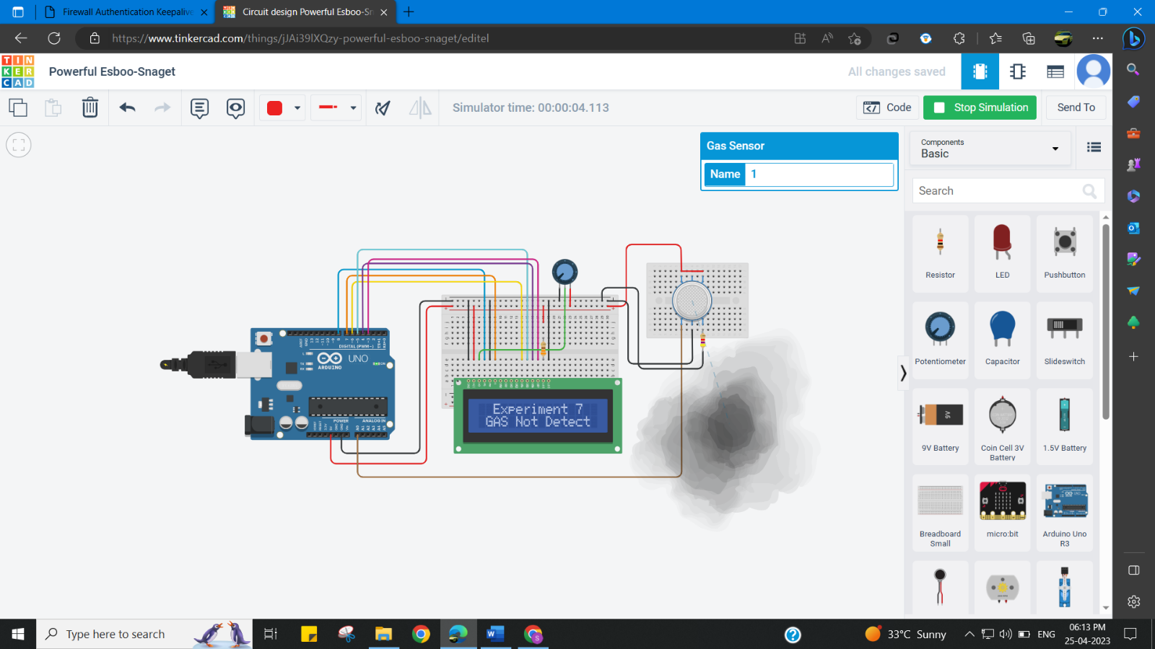

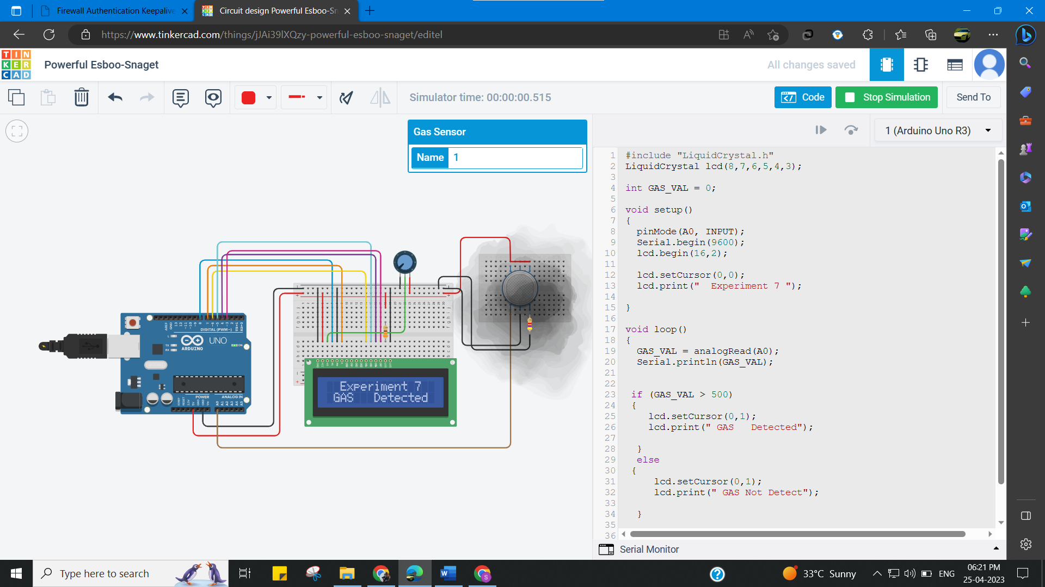

**Learning outcomes (What I have learnt):**

* Learn about LCD in detail.
* Learn about IoT programming.
* Display data generated by sensor on LCD using Arduino/Raspberry Pi.

**Evaluation Grid (To be created as per the SOP and Assessment guidelines by the faculty):**

|  |  |  |  |
| --- | --- | --- | --- |
| Sr. No. | Parameters | Marks Obtained | Maximum Marks |
| 1. |  |  |  |